Final Exam Case – Electronic Document Management System Case Study
You have been entrusted with the expansion of the previous exam project creation of an Electronic Document Management System. This EDMS now aims to revolutionize document handling processes, enhance collaboration, and ensure information accessibility across the organization. The project presents unique challenges and requires innovative approaches to integrate cloud support and intelligent Optical Character Recognition (OCR) capabilities seamlessly.
The EDM system has several new (expanded) unique features that just be developed for the first time in such an application. These new features should include all list from the Midterm Exam and should ALSO include the following features:
1. The EDMS must integrate with cloud storage services such as Amazon S3, Google Drive, or Microsoft OneDrive to provide scalable and secure document storage.
2. It should support seamless uploading, downloading, and synchronization of documents between the local repository and cloud storage.
3. It should allow users to create custom metadata fields and define taxonomy structures for organizing documents effectively.
4. The system must enforce granular access control policies to regulate document access based on user roles, permissions, and security clearance levels.
5. The EDMS should integrate with intelligent OCR technologies to automatically extract text and data from scanned documents, images, and PDF files.
6. It should employ machine learning algorithms to enhance OCR accuracy, support multilingual recognition, and handle complex document layouts effectively.
7. It should provide collaboration tools such as document sharing, commenting, and real-time co-authoring to facilitate seamless collaboration among users.
8. It should support notifications, alerts, and reminders for document-related activities and deadlines.
CSC-580 Fall 2025
Final Exam
The Final Exam is to be done in groups just like the breakout sessions (Distance Learners may complete individually). All members’ names must be put on each submission; however, each person is to submit a copy of the final exam on Canvas. The final page of the submission must have a team evaluation (1 or 2 paragraphs on the team’s participation). All work must be submitted electronically, to Canvas, and everything must be in one file (word or pdf).
Every group must work alone. IF I FIND ANY ARTIFACTS (i.e., drawings, etc.) COMMON BETWEEN TWO GROUPS THEN BOTH GROUPS GET A ZERO (0) FOR THE FINAL EXAM GRADE.
*** NO LATE SUBMISSION WILL BE ACCEPTED FOR ANY REASON! ***
Every group must work alone. IF I FIND ANY ARTIFACTS (i.e. drawings, etc.) COMMON BETWEEN TWO GROUPS THEN BOTH GROUPS GET A ZERO (0) FOR THE MIDTERM GRADE.
1. Components: (15 pts)
a. Document two candidate (2) components:
The two components selected for detailed documentation are:
1. Cloud Storage Integration Component — Manages seamless synchronization with cloud
services (Amazon S3, Google Drive, Microsoft OneDrive)
2. OCR & Document Processing Component — Handles intelligent optical character recognition,
text extraction, and multilingual support

1) define the component’s purpose is and how it accomplishes its goals and
1a) The Cloud Storage Integration Component serves as the bridge between the EDMS local repository
and external cloud storage providers. It abstracts the complexity of managing multiple cloud services
and provides a unified interface for document synchronization, upload, download, and backup
operations.
Primary Responsibilities:
1. Cloud Service Abstraction — Hide the specific implementation details of different cloud
providers (S3, Google Drive, OneDrive) behind a standardized interface
2. Bidirectional Synchronization — Maintain consistency between local and cloud repositories
through smart sync mechanisms
3. Scalable Storage Management — Leverage cloud infrastructure to support unlimited document
storage without local hardware constraints
4. Security & Encryption — Ensure documents are encrypted during transmission and at rest in
cloud storage
5. Error Handling & Retry Logic — Implement robust mechanisms to handle network failures,
timeouts, and partial uploads
6. Metadata Management — Preserve document metadata during cloud transfers and maintain
indexing for rapid retrieval
How It Accomplishes Goals:
The component uses a Strategy Pattern to support multiple cloud providers through pluggable
implementations. It implements:
CloudServiceAdapter interface — Standardizes operations across AWS S3, Google Drive, and
Microsoft OneDrive
Synchronization Engine — Uses change detection (hash-based) to identify modified documents
and sync only deltas
Connection Pooling — Maintains efficient connections to cloud services
Queue-Based Processing — Implements a task queue for asynchronous uploads/downloads to
prevent blocking operations
Encryption/Decryption Pipeline — Applies AES-256 encryption before cloud transmission
Comprehensive Logging & Audit Trail — Tracks all cloud operations for compliance and
debugging

2a) The OCR & Document Processing Component transforms scanned documents, images, and PDF files
into machine-readable, searchable digital formats. It integrates intelligent optical character recognition
technology with machine learning to enhance accuracy, support multilingual documents, and handle
complex layouts effectively.
Primary Responsibilities:
1. Document Type Detection — Automatically identify document type, format, and content category
2. Intelligent OCR Processing — Extract text from images and scanned documents with high
accuracy
3. Multilingual Support — Recognize and process documents in multiple languages (English,
Spanish, Chinese, etc.)4. Layout Preservation — Maintain document structure and formatting during text extraction
5. Machine Learning Enhancement — Use ML models to improve OCR accuracy over time
6. Data Validation & Correction — Detect and correct common OCR errors using dictionary and
context
7. Metadata Generation — Automatically extract and generate metadata (date, author, keywords)
8. Quality Scoring — Assign confidence scores to extracted text and flag uncertain sections
How It Accomplishes Goals:
The component implements a Pipeline Pattern with multiple processing stages:
DocumentProcessor interface — Standardizes processing across different document types
Multi-Stage Pipeline — Preprocessing, OCR, post-processing, and metadata extraction
ML Model Integration — Leverages trained neural networks for improved accuracy
Confidence Scoring — Maintains quality metrics for extracted data
Caching Layer — Stores processed results to avoid reprocessing identical documents
Error Recovery — Implements fallback strategies for difficult sections
Asynchronous Processing — Handles large documents without blocking the system

2) draw the component, including the classes that would be part of this component (be sure to identify the methods that would serve as the interfaces to this component also). You may use Internet resources as a starting point for the diagrams.
Component 1 Class Diagram
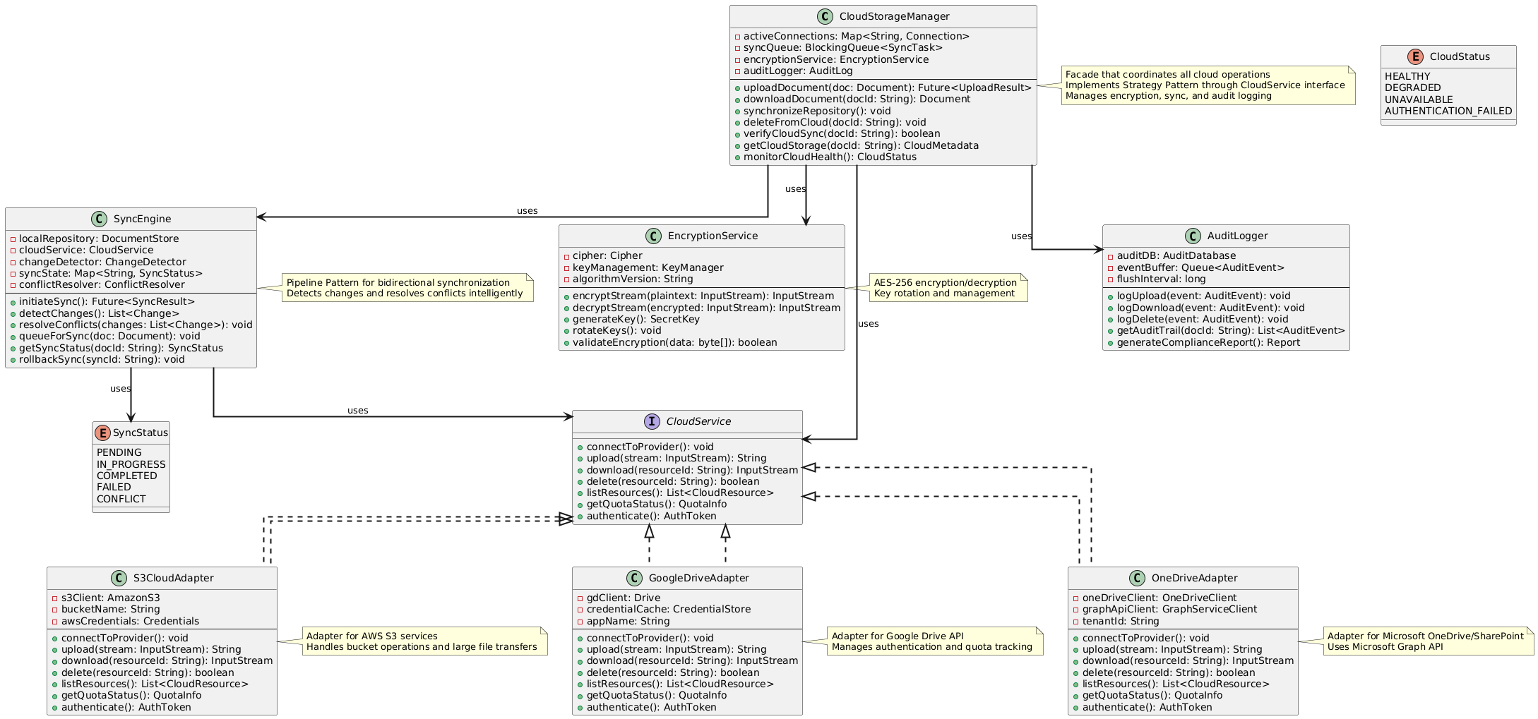
Component 2 Class Diagram
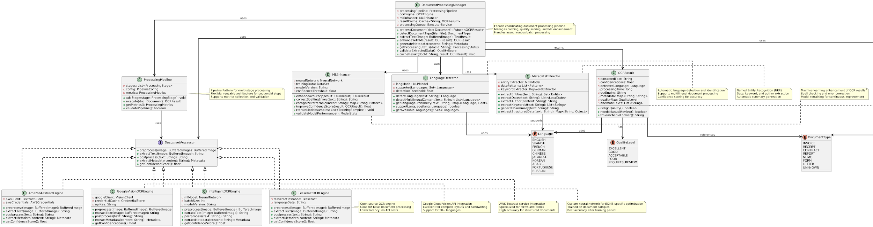

How they Integrate Diagram - for clarity
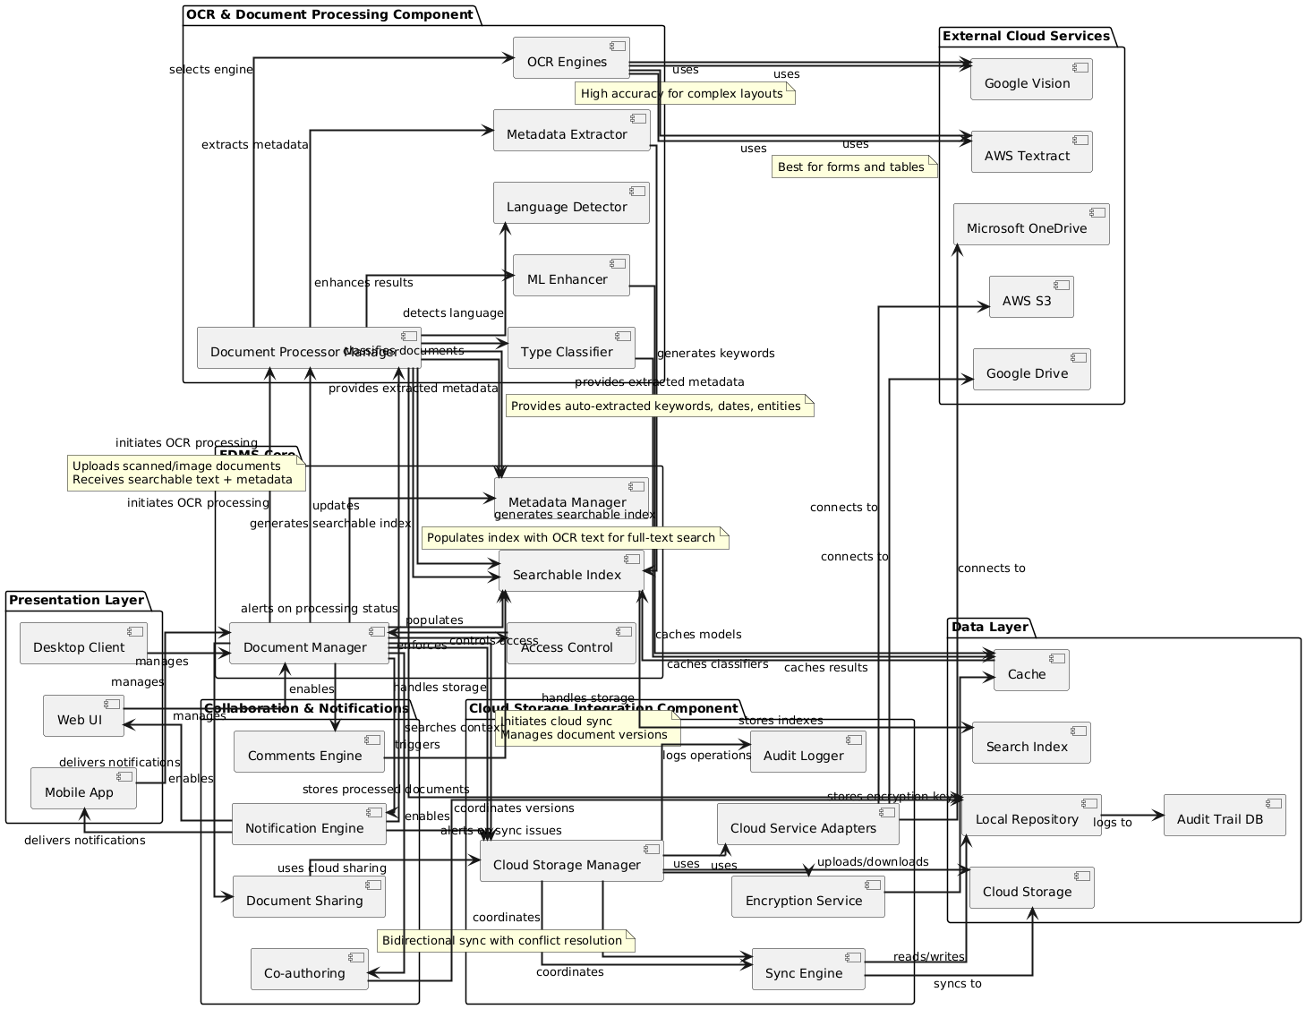
2. Architecture: (25 pts.)
a. Choose two (2) architectural styles that the team believes will be suitable for this application and draw them both. You may use Internet resources as a starting point for the diagrams.
b. Fill out the following table for your candidate architectures to determine if one, or both, styles you have selected could be a good choice.
c. Create a narrative response to answer in depth: 1) how the architecture styles were selected, 2) why they were selected (what purpose they should fulfill), 3) how they strengthen the enterprise environment (functionality it adds), and 4) which alternatives were evaluated.
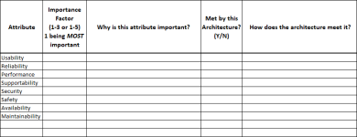
3. Framework: (25 pts.)
a. Choose two (2) Enterprise Framework styles that you feel would be suitable for this application and draw them both. You may use Internet resources as a starting point for the diagrams.
b. Fill out the following table for your candidate frameworks to determine if one, or both, frameworks you have selected could be a good choice.
c. Create a narrative response to answer in depth: 1) how the frameworks were selected, 2) why they were selected (what purpose they should fulfill), 3) how they strengthen the enterprise environment (functionality it adds), and 4) which alternatives were evaluated.

4. Design Patterns: (15 pts.)
a. Choose at least five (5) patterns that would be suitable to your system and describe:
i. How they were selected
ii. How they will be useful
iii. How they will be implemented
iv. How it will (or will not) be reused throughout the enterprise
5. Testing: (20 pts.)
a. Create a Test Plan - Describe in detail how the application will be tested – this will include:
i. Which testing scenarios will be utilized (regression and/or standard scenarios)
ii. Testing Roles
iii. Quality Assurance Vs. User Acceptance Scope
iv. Example Scenarios and Scripts
v. What will constitute successful tests and overall testing success
***A complete testing plan should be at least 10 pages in length with no obvious gaps
in the test plan and the included test scenarios. Please focus on including business and
technical testing strategies (including specialized testing covered in lecture), regression
testing, unit testing, TDD, etc.***

State of Michigan
(Insert System or Project Name Here)
(Insert Phase or Product Increment Here)
Detailed Test Plan

1.General Information

System or Project ID/Acronym: |  | Creation Date:
Client Agency: |  | Modification Date:
Author(s): |  | DTMB Authorized by:

2.Privacy Information
This document may contain information of a sensitive nature. This information should not be given to persons other than those who are involved with this system/project or who will become involved during its lifecycle.

3.Revision History
The Project Manager will maintain this information and provide updates as required. All updates to the Project Management Plan and component plans should be documented in this section.
Revision Date | Author | Section(s) | Summary

4.Overview
The Detailed Test Plan supports the test type details outlined in the project’s Test Strategy document. It details information for specific test phases (waterfall), or for an occurrence of Deploy Product Increment (agile) testing. The project’s Test Strategy document can be referenced to satisfy items in this plan.
Whenever the words “test phase” are used within this document this is in reference to either a specific test phase (waterfall) or for an occurrence of Deploy Product Increment (agile) testing.

Projects should complete the sections below or insert a link to other project documents containing the information.

5.Scope
Document the scope of what will be tested during this phase of testing. A list generated from the project’s testing tool can be inserted or a link added in lieu of completing the table.

5.1Items in Scope

Inputs to Testing (i.e. Module, Interface or Process Name/No.) | Functionalities/Features | Test Type(s)

5.2Items Out of Scope

Inputs to Testing (i.e. Module, Interface or Process Name/No.) | Functionalities/Features

5.3Test Scenarios

Test Scenario Number | Description of Scenario

5.4Test Cases

Test Case Number | Test Case Description

6.Test Phase Management
Please provide answers to the requested information below (or attach a link to a document or tool that contains the information).

6.1Objectives
Describe the business and technical goals of this test phase.

6.2Requirements Traceability
Provide links to tools that will contain the Requirements, Test Cases and Traceability, or describe how traceability will be established between Requirements and Test Cases. Insert links to the locations (SharePoint or tool) where these are stored.

6.3Data Management
Provide information on how often (and the process involved) the test data will be refreshed, backed up and restored etc., so that effective test planning and execution can take place.

6.4Pass Strategy
Document how tests will be executed in order to obtain a passed status (i.e. iteratively through multiple repetitions).

6.5Cycle/Iterations/Product Increment
Enter specific test types and tasks (i.e. Integration Testing, Regression Testing, batch processing, month-end reconciliation etc.) that are to be completed during each test cycle/iteration or product increment.

Testing Types/Tasks | Start Date for each Test Cycle/Increment/Product Increment | End Date for each Test Cycle/Increment/Product Increment

6.6 <Test Phase> Entry Criteria
Provide a list of factors/conditions that must be met before beginning the test execution in this phase.

6.7<Test Phase> Exit Criteria
Provide a list of factors/conditions that must be met before closing out this test execution in this phase.

7.Test Controls
Test Controls are used to monitor the test phase and provide status to the project.

7.1Key Dates and Deliverables
List all project deliverables and associated tasks including the information described in the tables below (or attach a list of tasks from the Enterprise Project Tracking Tool or any other tracking tool that contains these details).

Deliverable | Due Date | Responsible | Reviewer | Review Type
Refer to the Organizational Project Management Operating Procedures and the project’s Project Management Plan for the project for information on testing deliverables, review type and appropriate reviewers. Note any changes here.

7.2Test Milestones
Include milestones related to test planning, data preparation, automated testing, environment readiness, etc. for this test phase.

Test Phase Milestones | Start Date | End Date

7.3Change Request Management
If the project will be using procedures different from the procedures listed in the project’s Project Management Plan (PMP) then list the differences here.

7.4Defect Tracking and Defect Management
Describe how defects will be tracked and managed during this testing phase. An example is provided as a starting point in Appendix A – Example Defect Management Process for Waterfall Projects.

7.5Defect SLA for Resolution
Include a link to the project’s Test Strategy document or list each category of defect and the timeframes for identifying cause/fix and when retesting should occur.

Defect Severity | Timeframe for Analysis and Correction

7.6Metrics and Reporting
List the metrics being collected and reported during this test phase. Include reporting frequency, method, any tools used to gather and report the metrics and the intended audience.

7.7Escalation Path for Issues & Risks
If the project is utilizing a process other than the project Issues and Risk Management protocol, detail the leadership roles, stakeholders and other interested parties that must be notified of major issues or risks to this phase of testing.

8.Resources
Much of this information has been detailed in the Project’s Test Strategy. Only list deviations from that information in the sections below (e.g. additional resources needed, deviations to the customary environments for this type of testing or exceptional test data needs).

8.1Test Estimation
Provide an estimate for the number of hours/cost/duration of testing activities associated to this test phase or include a link to a document that contains this information. If needed, describe the estimation strategy used: Story points, hours, retrospective adjustments, past estimates, duration, etc.

8.2Test Environments
Describe the test environments that will be utilized for this phase of testing. Include a description of measures and controls that will ensure the integrity of the test results.

8.3Test Data Management
Describe the types of data required for the test and the approach that will be taken to obtain, create or refresh the necessary data.

8.4Test Resources
Please provide a list of roles needed to complete this phase of testing and identify the individual who will be assigned to that role.

Role* | Name | Role will be involved with this Type of Testing (Duties)

*Refer to the table of test roles defined in the Test Strategy document

9.Issues, Risks and Assumptions
Provide detail regarding assumptions, issues and risks that are associated with this test phase / product increment. Projects can insert a link to other planning documents, tools etc. where this information is already being tracked.

9.1Assumptions for this Phase of Testing
List any assumptions/issues/risks that may apply during this test phase. These are testing specific and are in addition to overall project assumptions/risks/issues.

Assumption Number | Assumption

9.2Issues for this Phase of Testing

Issue # | Description | Action | Responsible Resource | Due Date

9.3Risks for this Phase of Testing

Risk # | Description | Action | Responsible Resource | Due Date

10. Approvals
Approvers Signatures (must be authorized approvers/members of the project Change Control Board)
Role | Name/Title | Signature | Date
Business Owner (Authorized Approver)

DTMB System Owner (if identified)

Project Manager

Project Test Manager

11.Appendix A – Example Defect Management Process for Waterfall Projects
The following table provides an example of the required steps of a “Defect Management Process”. Projects/Organizations may need to customize this approach to be specific to their environment and procedure.
Step | Role | Action to be Taken
1 | Tester | Logs the defect into the defect tracking tool along with all pertinent details regarding how to recreate the defect. The tester assigns the defect(s) to the Developer Lead.
2 | Developer Lead | Assigns the “NEW” defect to a developer and changes the status to “OPEN”.
3 | Developer | Triages the “OPEN” defect. If the developer determines the defect is not a unique defect or cannot recreate the defect, the developer sets the status to “REJECT” and enters a reason code of “Cannot Duplicate”, “No Trouble Found” or “Duplicate”. If the Developer can confirm the defect and the defect needs to be corrected to comply with quality guidelines, the developer will correct the defect and set the status to “READY TO RETEST”. If the Developer can confirm the defect and the defect should not be corrected prior to release deployment, the Developer will set the status to “Deferred”.
4 | Tester | Validates all “READY TO RETEST” defects. If the tester finds that the functionality is working fine; the defect status will be changed as “CLOSED”. If tester finds that the malfunction still exists, the tester will change the status of the defect to “REOPEN”. The Reopened defects will again go through the defect life cycle.
5 | Tester | If a defect is set to the status of ‘REJECT’ by the developer, the Tester should review the defect and determine if they agree with the developer’s explanation as to why it is not a defect. If the Tester believes the defect should stand, it should be discussed in the daily triage meeting. If the tester agrees with the Rejected status, the Tester should close the defect.
6 | Developer Lead/Business Owner | Any Defects with a status of “Deferred” are reviewed with the Business Owner prior to the Stage Exit. Deferred defects should be considered new items and prioritized within the current project processes for new item consideration.

